**Environmental Impacts of Diet Groups**

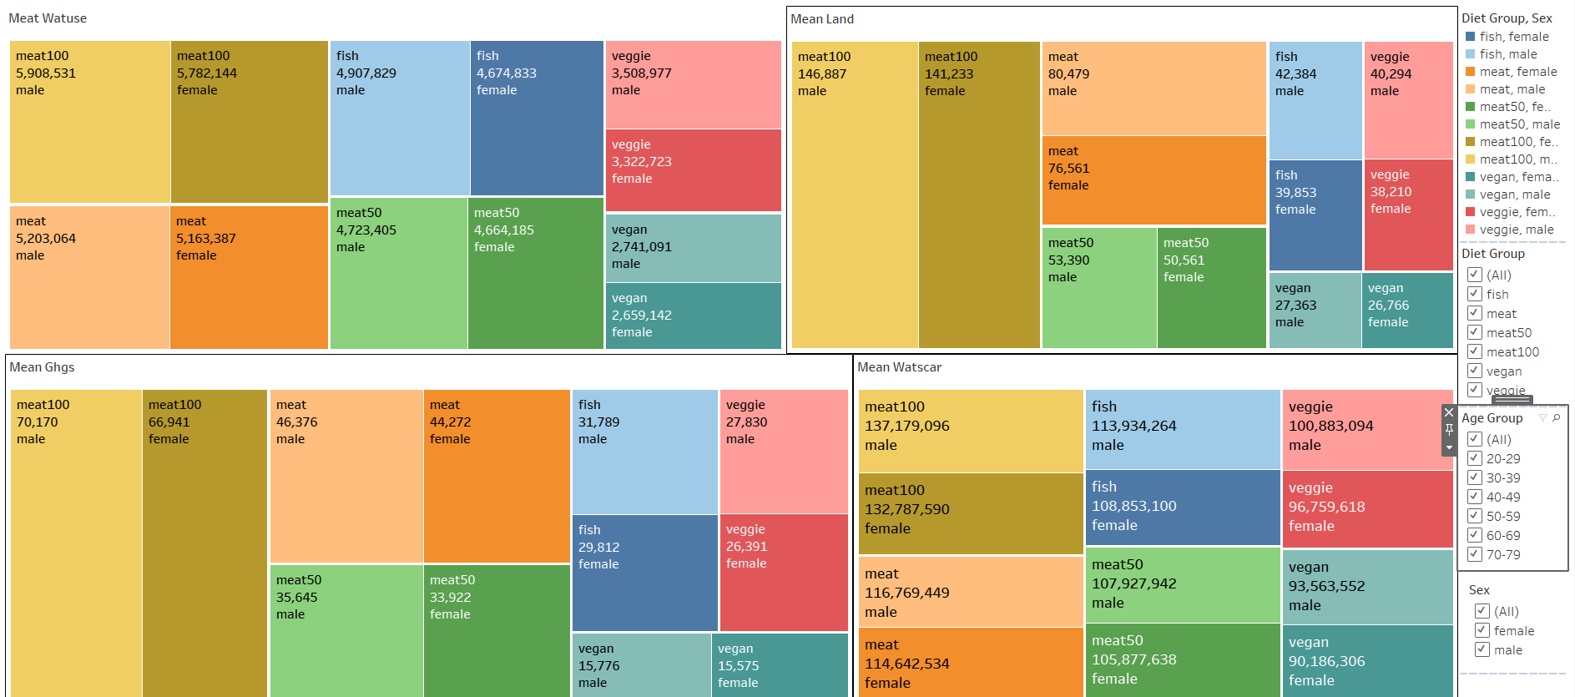

**Visual Design Type**: Treemap plot

**Name of Tool**: Tableau

**Diet Groups**: Meat100, Meat50, Fish, Vegan, Vegetarian

**Variables**: mean_ghs, mean_land, mean_watuse, mean_watscar

**The variables/data attributes shown**:

Diet Groups are chosen as the fundamental to the study as they represent a spectrum of dietary habits from high meat consumption to complete plant-based diets. GHG emissions are a primary factor to understand the impact on environment across different diet groups. Land use is crucial for understanding the spatial food production, relevant for assessing habitat disruption and biodiversity loss. Water use directly correlates with the sustainability of a diet, especially in regions facing water scarcity.

**Visual Mappings**:

1. Color: Each diet group and sex combination are represented by a different color across all the metrics, making it easy to distinguish between them.

2.Size: The size of each rectangle is proportional to the summation value of the respective metric(mean_ghs, mean_land, mean_watuse, mean_watscar) by each diet group and sex, which visually encodes the magnitude of metrics.

3.Position: Rectangles are organized from left to right, top to bottom, grouping similar diet categories together and ordered generally from highest to lowest values.

4. Hierarchy: The overall hierarchy is determined by diet groups and sex for each metrics. (mean_ghs, mean_land, mean_watuse, mean_watscar)

**Unique Observations**:

The visualization reveals distinct trends highlighting the environmental implications of diets with varying levels of meat consumption. Notably, diets characterized by higher meat content, such as the Meat100 group, consistently exhibit more significant environmental impacts across multiple metrics, including greenhouse gas emissions, water use, and land utilization for both male and females. This is evident from the larger rectangles representing the Meat100 group in contrast to those depicting diets with greater reliance on plant-based foods. Conversely, plant-based diets, vegan and vegetarian diets, are depicted with comparatively smaller rectangles across these metrics, indicative of their comparatively lower environmental footprint.

The data suggest a positive correlation between greenhouse gas emissions and land use across all the diet groups. The Meat100 group, which records the highest values for greenhouse gas emissions, also uses the most land, primarily due to the extensive land requirements for livestock and feed production. On the other end, vegan and vegetarian diets demonstrate low figures for both greenhouse gas emissions and land use, that shows these diets are more sustainable due to their minimal reliance on land and their lower emission levels. The similar observation can be seen if compared at different gender levels.

Furthermore, there is a correlation between water use and water scarcity impacts. Diets with higher meat content (Meat100 and Meat50) not only use more water but also contribute significantly to water scarcity issues. This suggests that the volume of water utilized by a diet directly affects its impact on water-scarce regions. Again, vegan, and vegetarian diets show advantages, with lower values in both metrics, which indicates their suitability in regions vulnerable to water scarcity.

The uniform trend of high environmental impacts associated with the Meat100 group underscores the substantial environmental costs tied to high meat consumption diets. This group consistently emerges as an outlier, that shows negative environmental outcomes across all measured metrics.

**Data Preparation**:

To prepare the data for this visualization, I have aggregated mean values for each metric by diet group, ensuring each metric was properly summed as needed to provide a meaningful comparison across groups.

**Youtube Link**: https://youtu.be/uc6rmzgj0Yw